Fuber Project Summary

**Problem Statement**

* There is an excess of wasted food leading to wasted money and resources.

**Project Goals & objectives**

* To build a working app that promotes and encourages food waste reduction.
* Develop a habit of saving and keeping track of food.

**Gather requirements**

* The app should allow users to store food items in their kitchen by scanning a QR code on their grocery.
* By scanning food items, users are provided suggestions on recipes.
* Food kept in a user’s kitchen can be organized based on food types and where in the kitchen it is stored (ie. Fridge, pantry, freezer)

**Project Timeline**

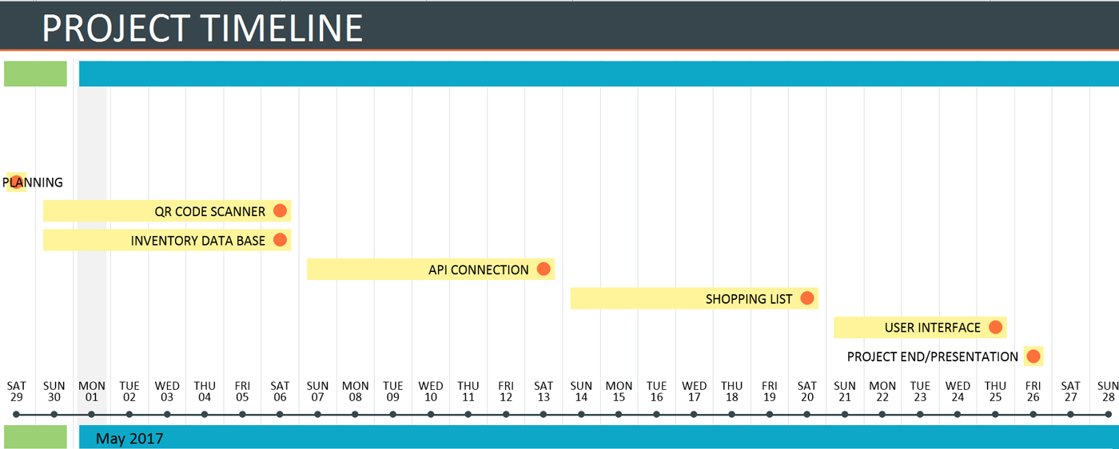

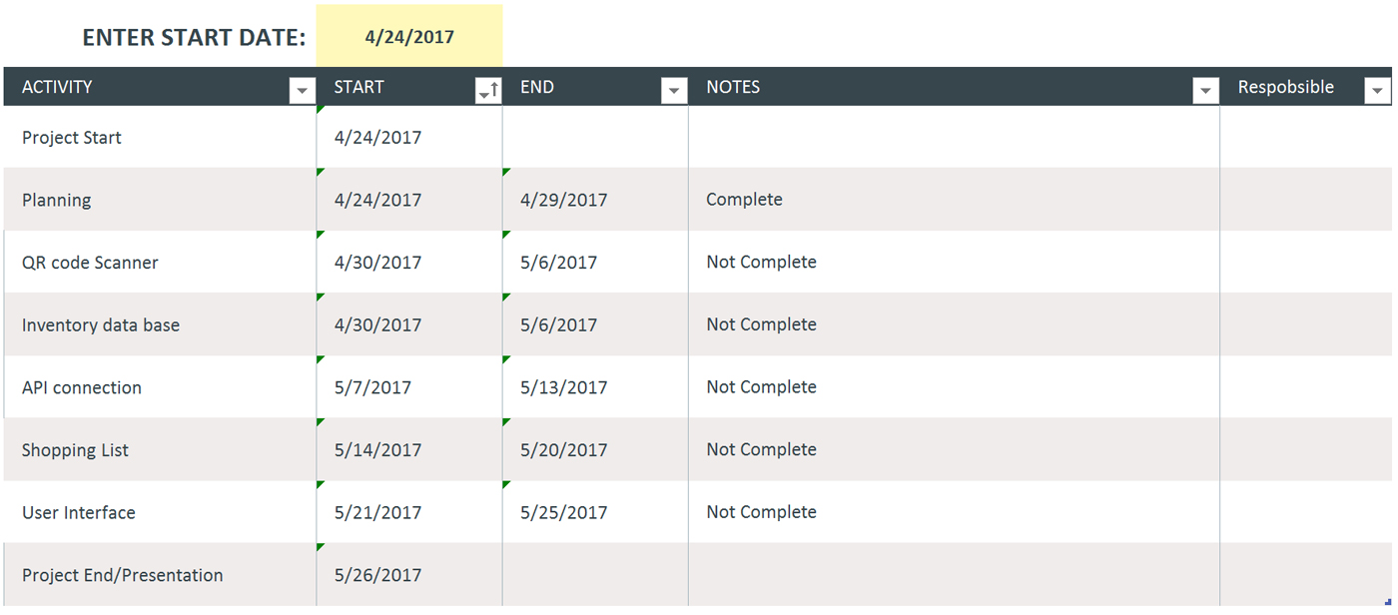

**Success criteria**

* The app allows the user to input data without hassle.
* The user interface is easy to navigate for all users and age groups.
* Ensures smooth control that leads to as few bugs as possible.
* Can run on various devices.
* App should be able to accurately keep track of food in the kitchen
* App is used as a daily food journal/shopping list

**Assumptions**

* Users may forget to update or keep track of the list of food items.
* All users have average adult diets/appetites.
* Users may not be aware of the problem.
* Users may lose interest in using the app.

**Risks**

* Conflicting ideas between team members.
* May not raise awareness of the subject matter.
* An complicated UI consisting of tedious data entry leading to potential loss of interest from the end users.
* Excessive scope for allotted time.
* Possible bugs affecting development time.
* End goal not yet fully specified.

**Stakeholders**

* End users
* COMP 2910 markers
* BCIT staff
* Metro Vancouver

**Approval**

* Markers
* Copyright
  + Authorized usage of images, info , and various things used for the project